６．My favorite movie

Step1 先生のお気に入りの映画について聞き取れたことを書こう！

映画の名前は？
作者は誰？
公開年は？
主役の俳優は？
シリーズ何作ある？

Step2 聞き取れた方に丸を付けよう！
My favorite movie is Harry Potter. Harry potter is one of the famous movies in the world. Harry Potter ①(write/was written) by Joanne Rowling. The first episode of the series ②(was released/have released) in 2001. The leading character, Harry Potter is played ③ (for/by) Daniel Radcliffe. This series has eight episodes in total. This movie recorded sales of 7,700 million dollars.

Step3 わかったこと！

Joanne Rowling wrote Harry Potter. （訳＿＿＿＿＿＿＿＿＿＿＿＿＿）
S V O
Harry Potter was written by Joanne Rowling. （訳＿＿＿＿＿＿＿＿＿＿＿＿＿）

能動態における（ ）が受動態では主語になり、
S ＋ （ ） ＋ （ ） ～の形をとる。
（ ）という受け身の意味を表す。

疑問文では、be動詞＋S＋p.p.の形をとる
Ex)Was Harry Potter Written by Joanne Rowling?
Step4 ペアで映画を紹介し合おう！

Model Dialogue
A : Hello. How are you?
B : Hello. I’m (fine, sleepy, hungry…). How about you?
A : I’m (fine, sleepy, hungry…). Do you know about Herry Potter.
B : Yes, I do. I (love, have seen, don’t like)Herry Potter.
A : Who is the author?
B : Herry Potter is written by Joanne Rowling.
A : When was the movie released?
B : The first episode of the series was released 2001.
A : Who is the leading character?
B : The leading character is played by Daniel Radcliffe.
A :( That’s nice. / I see. / I didn’t know that.)
B : Do you know about 映画の名前?
・
・
・
A : Nice talking with you.
B : Nice talking with you, too.

Step5 自分のお気に入りの映画について５０字以上で書こう！

作者、いつ放映されたか、主演は誰か、シリーズは何作あるか、
どんな映画か、など様々な情報を入れよう

Step4 Work SheetA

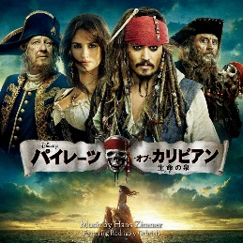  作者 ( )  放映年 ( )  主演 ( )  Pirates of the Caribbean | 作者 Yoichi Komori  放映年 2004  主演 Hideaki Ito  UMIZARU
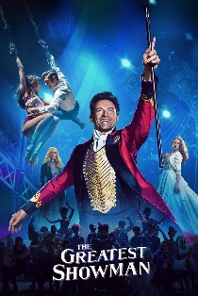  作者 ( )  放映年 ( )  主演 ( )  Greatest Showman | 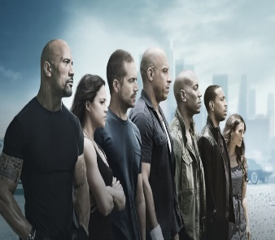  作者 Gary Thompson  放映年 2001  主演 Paul Walker  The Fast and the Furious
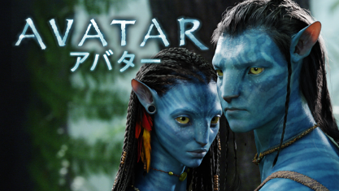  AVATAR  作者 ( )  放映年 ( )  主演 ( ) | 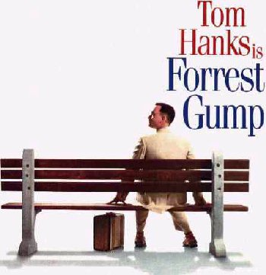  作者 Winston Groom  放映年 1994  主演 Tom Hanks  Forrest Gump

Step4 Work Sheet2

作者 Ted Elliott  放映年 2003  主演 Johnny Depp  Pirates of the Caribbean | 作者 ( )  放映年 ( )  主演 ( )  UMIZARU
作者 Jenny Bicks  放映年 2017  主演 Hugh Jackman  Greatest Showman | 作者 ( )  放映年 ( )  主演 ( )  The Fast and the Furious
AVATAR  作者 James Cameron  放映年 2009  主演 Sam Worthington | 作者 ( )  放映年 ( )  主演 ( )  Forrest Gump

