**BINGO GAME**

**Name: [ ]**

|  |  |  |
| --- | --- | --- |
|  |  |  |
|  |  |  |
|  |  |  |

**Countries:**

America: [](http://www.google.co.jp/url?sa=i&rct=j&q=&esrc=s&source=images&cd=&cad=rja&uact=8&ved=0ahUKEwjF-aD7hJ3YAhVGU7wKHTe_A6cQjRwIBw&url=http://www.abysse.co.jp/world/flag/america/america.html&psig=AOvVaw0zRPe9CAKZYnCT9ym5OdM4&ust=1514012161801593) 　Australia: [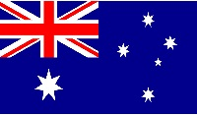](http://www.google.co.jp/url?sa=i&rct=j&q=&esrc=s&source=images&cd=&cad=rja&uact=8&ved=0ahUKEwj25KWZhZ3YAhUKWLwKHWrRDKYQjRwIBw&url=http://auvibes.com/archives/1181&psig=AOvVaw34wob2rgltD9iNgmQHgRIh&ust=1514012222352645) Brazil: [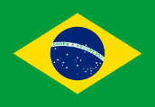](https://www.google.co.jp/url?sa=i&rct=j&q=&esrc=s&source=images&cd=&cad=rja&uact=8&ved=0ahUKEwiJ-PayhZ3YAhWEU7wKHS8pA3oQjRwIBw&url=https://ja.wikipedia.org/wiki/%E3%83%96%E3%83%A9%E3%82%B8%E3%83%AB%E3%81%AE%E5%9B%BD%E6%97%97&psig=AOvVaw2wXo7yVfeHbL5JsiYoSnNU&ust=1514012279277561)

China: [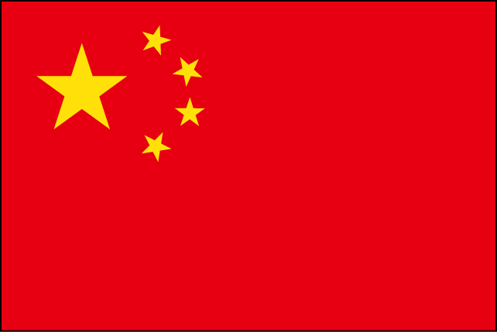](http://www.google.co.jp/url?sa=i&rct=j&q=&esrc=s&source=images&cd=&cad=rja&uact=8&ved=0ahUKEwiClvXQhZ3YAhULfbwKHdo2DaYQjRwIBw&url=http://www.civillink.net/sozai/kakudai/sozai2660.html&psig=AOvVaw2O0ID0fBN3seDpibdbPG5v&ust=1514012339992720) Egypt: [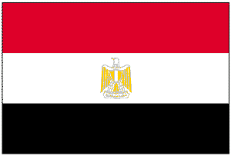](https://www.google.co.jp/url?sa=i&rct=j&q=&esrc=s&source=images&cd=&cad=rja&uact=8&ved=0ahUKEwiq1KvthZ3YAhULjLwKHWqMC5MQjRwIBw&url=https://detail.chiebukuro.yahoo.co.jp/qa/question_detail/q1063577845&psig=AOvVaw3TYax4fHr506WpREZrlcMr&ust=1514012397563299) India: [](https://ja.wikipedia.org/wiki/%E3%82%A4%E3%83%B3%E3%83%89%E3%81%AE%E5%9B%BD%E6%97%97)

Greece: [](http://www.google.co.jp/url?sa=i&rct=j&q=&esrc=s&source=images&cd=&cad=rja&uact=8&ved=0ahUKEwiPlfK1hp3YAhXGV7wKHcHNC6MQjRwIBw&url=http://flagpedia.asia/ja/greece&psig=AOvVaw3quANZYBkXKunSjRcimRyF&ust=1514012553870326) Japan: [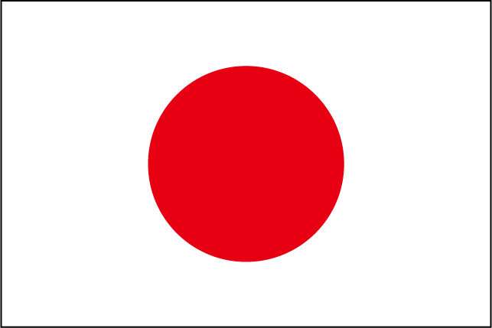](http://www.google.co.jp/url?sa=i&rct=j&q=&esrc=s&source=images&cd=&cad=rja&uact=8&ved=0ahUKEwi2__zchp3YAhUJzbwKHVpzBaMQjRwIBw&url=http://tamenal.com/32806&psig=AOvVaw1roOmxXciy0W4Gb9rTY3Gd&ust=1514012622588494) Spain: [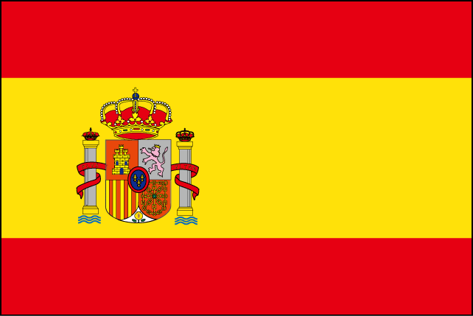](http://www.google.co.jp/url?sa=i&rct=j&q=&esrc=s&source=images&cd=&cad=rja&uact=8&ved=0ahUKEwi6vr2Jh53YAhUMgbwKHUEdBqMQjRwIBw&url=http://www.civillink.net/sozai/kakudai/sozai2615.html&psig=AOvVaw3q1izDaMUTwfVmaJ9V8o27&ust=1514012726395586)

France: [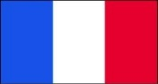](https://www.google.co.jp/url?sa=i&rct=j&q=&esrc=s&source=images&cd=&cad=rja&uact=8&ved=0ahUKEwj828ijh53YAhUG6bwKHbhFAJgQjRwIBw&url=https://www.amazon.co.jp/%E6%9D%B1%E4%BA%AC%E8%A3%BD%E6%97%97%E6%A0%AA%E5%BC%8F%E4%BC%9A%E7%A4%BE-%E3%83%95%E3%83%A9%E3%83%B3%E3%82%B9%E5%9B%BD%E6%97%97%E3%83%88%E3%83%AA%E3%82%B3%E3%83%AD%E3%83%BC%E3%83%AB-70%C3%97100%EF%BD%83%EF%BD%8D%E3%83%BB%E3%83%9D%E3%83%AA%E3%82%A8%E3%82%B9%E3%83%86%E3%83%AB100%EF%BC%85/dp/B0095ETS14&psig=AOvVaw0rzjwoT5-ywcEYPLw0uDQx&ust=1514012783601590) Norway: [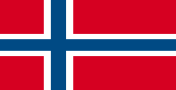](http://www.google.co.jp/url?sa=i&rct=j&q=&esrc=s&source=images&cd=&cad=rja&uact=8&ved=0ahUKEwjDvce9h53YAhUSh7wKHVFnBKEQjRwIBw&url=http://freesozai.jp/itemList.php?category%3Dnation_flag%26page%3Dntf_323%26type%3Dsozai&psig=AOvVaw2oMjU-UMthlQAPzCBpGZn5&ust=1514012837058235)