[](https://www.google.co.jp/url?sa=i&rct=j&q=&esrc=s&source=images&cd=&cad=rja&uact=8&ved=2ahUKEwi7s_XY6fjfAhVQA4gKHYH6BdkQjRx6BAgBEAU&url=http%3A%2F%2Fwww.wanpug.com%2Fillust3.html&psig=AOvVaw35FcJbDDLkEHcRgLpc2TWG&ust=1547952261777439)

dog

[](https://www.google.co.jp/url?sa=i&rct=j&q=&esrc=s&source=images&cd=&cad=rja&uact=8&ved=2ahUKEwj4vZOp6vjfAhUMA4gKHafxC6gQjRx6BAgBEAU&url=https%3A%2F%2Fillust-imt.jp%2Farchives%2F005806%2F&psig=AOvVaw17qdNUI5fUtrwZpG1g6qP1&ust=1547952430101457)cat

[](https://www.google.co.jp/url?sa=i&rct=j&q=&esrc=s&source=images&cd=&cad=rja&uact=8&ved=2ahUKEwjYkpXS6vjfAhWNF4gKHeygANQQjRx6BAgBEAU&url=https%3A%2F%2Fmatome.naver.jp%2Fodai%2F2135566204797482301&psig=AOvVaw0J1fN62A9ws1rMBvKuak0s&ust=1547952508912596)elephant

[](https://www.google.co.jp/url?sa=i&rct=j&q=&esrc=s&source=images&cd=&cad=rja&uact=8&ved=2ahUKEwik_9-u6_jfAhWUBIgKHfW5DrQQjRx6BAgBEAU&url=https%3A%2F%2Fmatome.naver.jp%2Fodai%2F2146668596713924701&psig=AOvVaw0z4RISXCtNK8cFRih7BtSW&ust=1547952701307579)lion

[](https://www.google.co.jp/url?sa=i&rct=j&q=&esrc=s&source=images&cd=&cad=rja&uact=8&ved=2ahUKEwiCk47I6_jfAhUGBIgKHdTGCesQjRx6BAgBEAU&url=https%3A%2F%2Fwww.sozai-library.com%2Fsozai%2F9532&psig=AOvVaw3lLi1cfH_iIYYh4DBuz1Lz&ust=1547952763209658)rabbit

[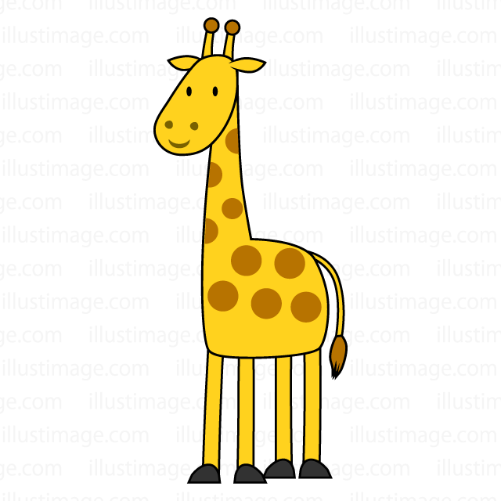](https://illustimage.com/?id=1466)giraffe

[](https://www.google.co.jp/url?sa=i&rct=j&q=&esrc=s&source=images&cd=&ved=2ahUKEwjnpIeB7PjfAhUaQd4KHbiwCPkQjRx6BAgBEAU&url=http%3A%2F%2Fflode-design.com%2F%3Fp%3D692&psig=AOvVaw1-ViDFJFgIKzmmnz_d_8Wf&ust=1547952874081417)apple

[](https://www.google.co.jp/url?sa=i&rct=j&q=&esrc=s&source=images&cd=&cad=rja&uact=8&ved=2ahUKEwjX1bmc7PjfAhWVIIgKHUm_BmAQjRx6BAgBEAU&url=http%3A%2F%2Fwww.pictcan.com%2Fitem%2F0038.html&psig=AOvVaw0-M8-Z7CO95YYxr63BuSbd&ust=1547952936821992)banana

[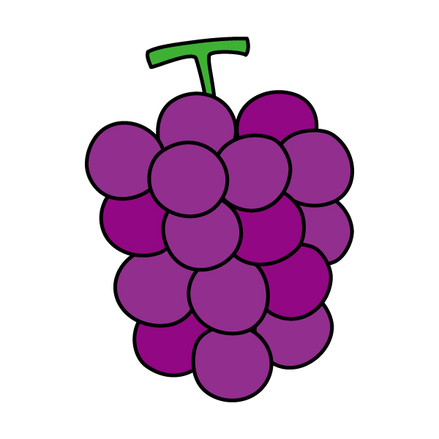](https://www.sozailab.jp/sozai/detail/22885/)grape

[](https://www.google.co.jp/url?sa=i&rct=j&q=&esrc=s&source=images&cd=&cad=rja&uact=8&ved=2ahUKEwjAsKvQ7PjfAhURUN4KHZ89D3sQjRx6BAgBEAU&url=https%3A%2F%2Fillustimage.com%2F%3Fid%3D484&psig=AOvVaw36qgT0f3pDfmXI1dq2HfUA&ust=1547953049242822)peach

[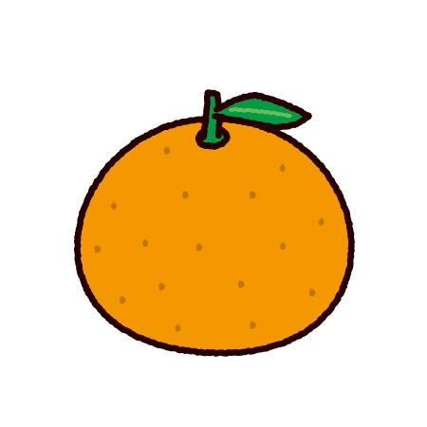](https://www.google.co.jp/url?sa=i&rct=j&q=&esrc=s&source=images&cd=&ved=2ahUKEwih2I7o7PjfAhVHdt4KHbtyBpEQjRx6BAgBEAU&url=https%3A%2F%2Fillustkun.com%2Fmandarin-orange%2F&psig=AOvVaw35AV6uz1UXMX5TLO30I1SX&ust=1547953096966947)orange

[](https://www.google.co.jp/url?sa=i&rct=j&q=&esrc=s&source=images&cd=&cad=rja&uact=8&ved=2ahUKEwjfwOGH7fjfAhXWfXAKHWKGAagQjRx6BAgBEAU&url=https%3A%2F%2Fwww.irasutoya.com%2F2014%2F01%2Fblog-post_22.html&psig=AOvVaw09ND0WWqgFUzjLoXAS9evv&ust=1547953165609023)baseball

[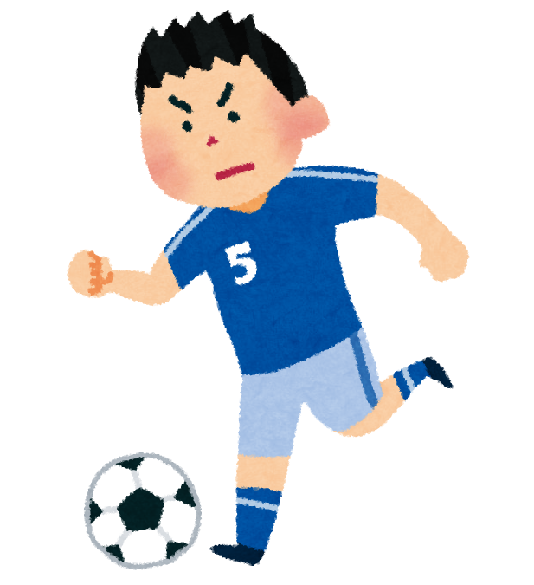](https://www.google.co.jp/url?sa=i&rct=j&q=&esrc=s&source=images&cd=&cad=rja&uact=8&ved=2ahUKEwiO1oaf7fjfAhVP7WEKHR31BPMQjRx6BAgBEAU&url=https%3A%2F%2Fwww.irasutoya.com%2F2013%2F09%2Fblog-post_7157.html&psig=AOvVaw2j-UYQwtMFrGz-55QaCLKf&ust=1547953215367004)soccer

[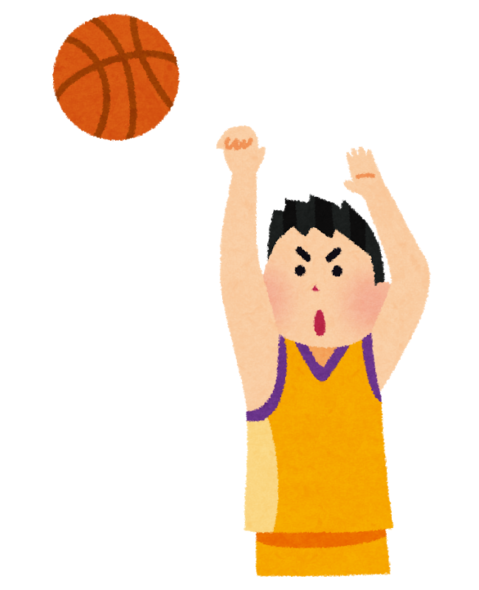](https://www.google.co.jp/url?sa=i&rct=j&q=&esrc=s&source=images&cd=&cad=rja&uact=8&ved=2ahUKEwiizcLB7fjfAhVNUt4KHfyZBZIQjRx6BAgBEAU&url=https%3A%2F%2Fwww.irasutoya.com%2F2014%2F08%2Fblog-post_268.html&psig=AOvVaw00vcuhQV7i1H-lSprNW7tW&ust=1547953285066456)basketball

[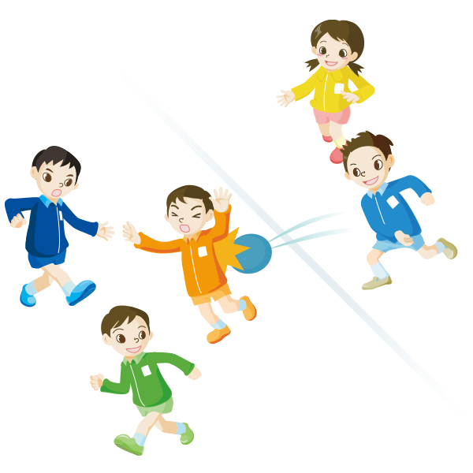](https://www.google.co.jp/url?sa=i&rct=j&q=&esrc=s&source=images&cd=&cad=rja&uact=8&ved=2ahUKEwjbt_uG7vjfAhVF7GEKHUAADpkQjRx6BAgBEAU&url=https%3A%2F%2Fwww.jpnsport.go.jp%2Fanzen%2Fanzen_school%2Fdownload%2Ftabid%2F1662%2FDefault.aspx&psig=AOvVaw1kaFysYVvN_iZEoPMAkgVh&ust=1547953419622681)dodge ball

[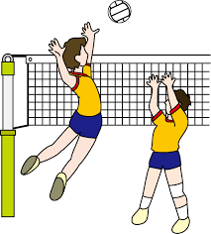](https://www.google.co.jp/url?sa=i&rct=j&q=&esrc=s&source=images&cd=&ved=2ahUKEwi-k5Sf7vjfAhWFZt4KHRKQApYQjRx6BAgBEAU&url=https%3A%2F%2Fillpop.com%2Fsport_a08.htm&psig=AOvVaw1DAw3Bhas68GGv6MpJlnlk&ust=1547953482918142)volleyball

[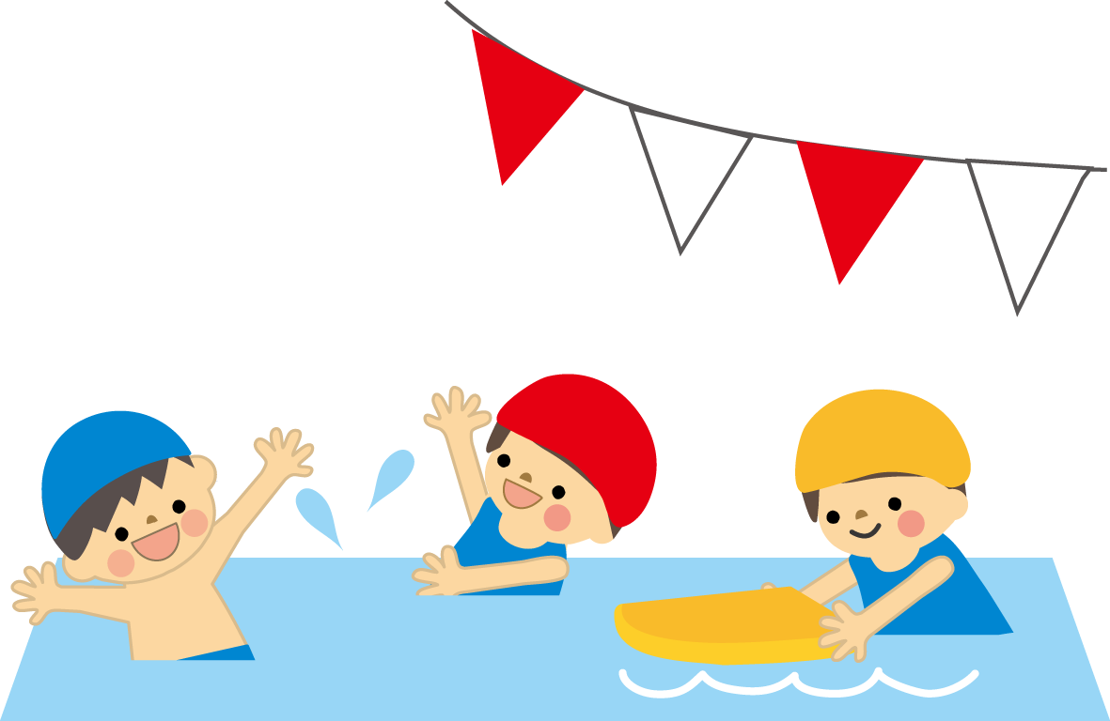](https://www.google.co.jp/url?sa=i&rct=j&q=&esrc=s&source=images&cd=&ved=2ahUKEwjDmoq87vjfAhVaEnAKHVsMA84QjRx6BAgBEAU&url=http%3A%2F%2Fkids.wanpug.com%2Fillust214.html&psig=AOvVaw11HRhjhOOOzh417bcH8CM4&ust=1547953541799401)swimming