|  |  |  |  |
| --- | --- | --- | --- |
|  |  |  |  |
|  |  |  |  |
|  |  |  |  |
|  |  |  |  |
|  |  |  |  |
|  |  |  |  |

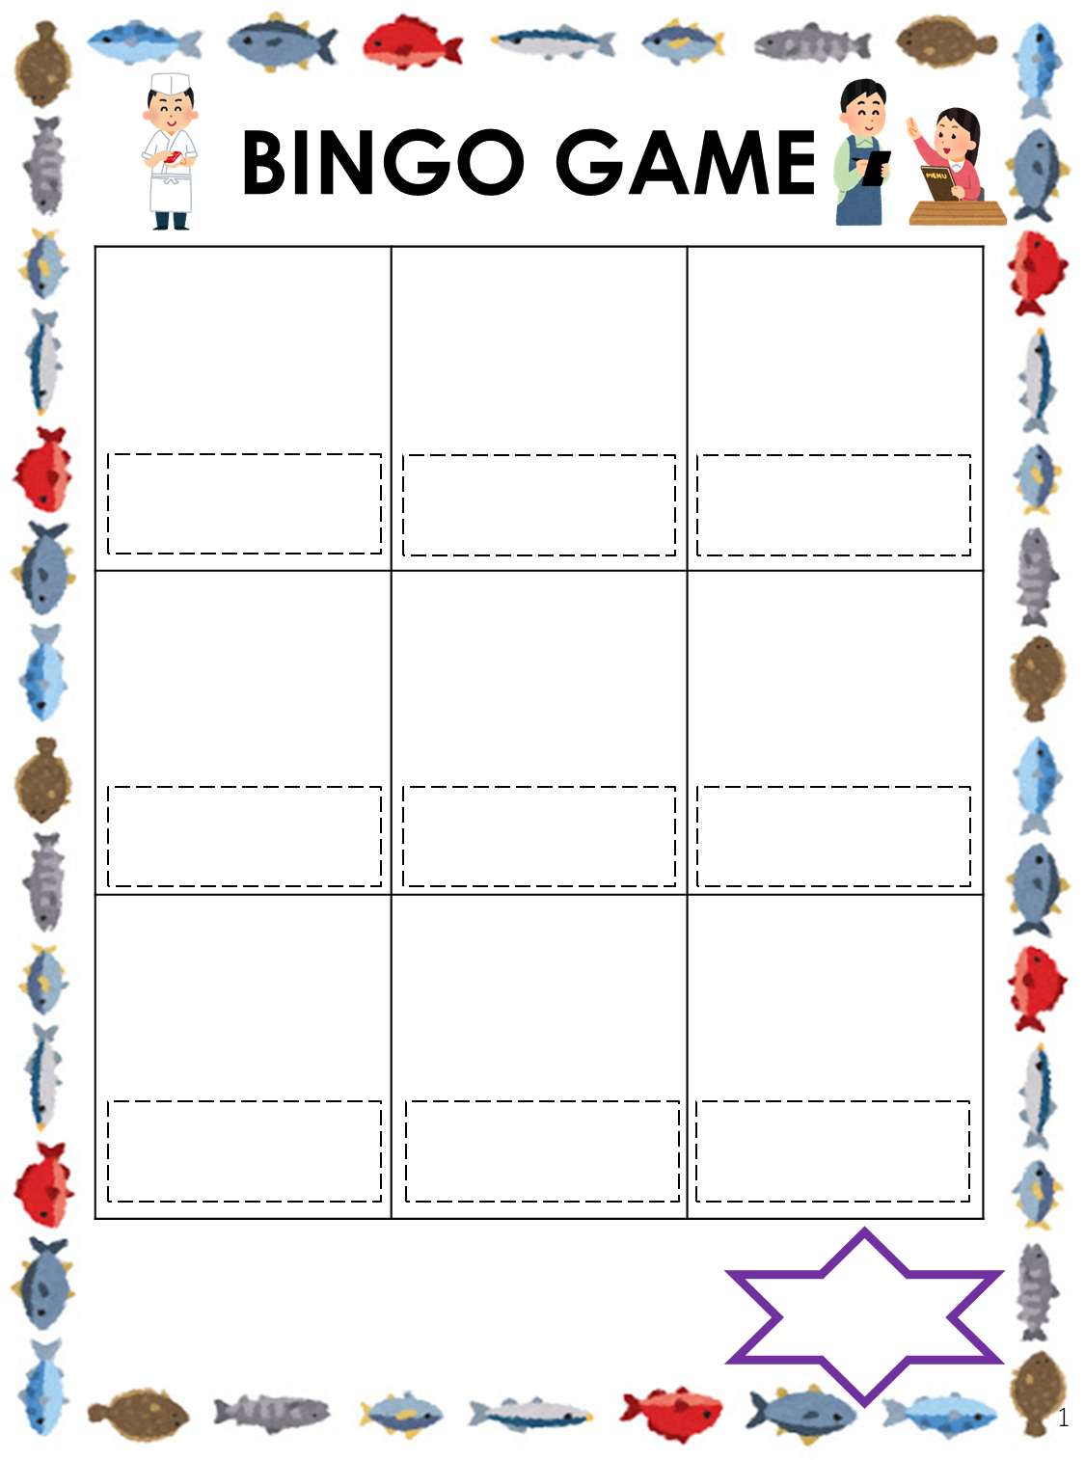

|  |  |
| --- | --- |
| **gyaza** | **rice** |
| **grilled fish** | **rice ball** |
| **ice cream** | **salad** |
| **omelet** | **spaghetti** |
| **parfait** | **yogurt** |
| **pizza** | **beefsteak** |
| **ramen** | **cake** |
| **corn soup** | **curry and rice** |
| **daifuku** | **French fries** |
| **fried chicken** | **fruits** |
| **bread** |  |