・It’s something to eat.  ・It is sweet.  ・We eat it in a birthday.  What is it?  <a cake> | ・It’s something to eat.  ・The shape is round.  ・The color is red.  What is it?  <an apple> | ・It’s something to eat.  ・We eat it in the New Year’s Day.  ・The color is white.  What is it?  <a rice cake（もち）>
・It’s something to drink.  ・We drink it at lunch.  ・The color is white.  What is it?  <milk> | ・It’s something to read.  ・We read it in the morning.  ・We get information.  <newspaper> | ・It’s something to drink.  ・We drink it in the morning.  ・The color is black.  <coffee>
・It’s something to eat.  ・We eat it in summer.  ・We eat many kinds of flavors.  What is it?  <shaved ice（かき氷）> | ・It’s something to eat.  ・We eat it in summer.  ・The colors are green and black.  What is it?  <watermelon> | ・It’s something to drink.  ・The taste is lemon.  ・It’s a kind of soda.  What is it?  <CC Lemon>
・It’s something to watch in summer.  ・It’s colorful.  ・We watch them in the sky.  What is it?  <fireworks> | ・It’s a book to read.  ・It’s famous all over the world.  ・It has 7 main characters.  What is it?  <One Piece> | ・It’s a book to read.  ・It’s famous all over the world.  ・It has 8 series.  What is it?  <Harry Potter>
・It’s something hot to drink.  ・It is sweet.  ・We drink it in winter.  What is it?  <hot cocoa> | ・It’s something to eat.  ・We eat it in winter.  ・The color is orange.  What is it?  <an orange> | ・It’s a book to read.  ・It has many stories.  ・Boys like it.  What is it?  <JUMP>

・It’s something to eat.  ・We eat it in autumn.  ・The color is brown.  What is it?  <a chestnut（栗）> | ・It’s something to watch in spring.  ・We enjoy to watch it.  ・The color is pink.  What is it?  <a cherry blossom（桜）> | ・It’s something to eat in autumn.  ・It is sweet.  ・The color is purple.  What is it?  <a sweet potato（さつまいも）>
・It’s something to make in winter.  ・It has a head and a body.  ・It has eyes.  What is it?  <a snowman（雪だるま）> | ・It’s something to make in winter.  ・The color is white.  ・It is a dome.  What is it?  <an igloo（かまくら）>

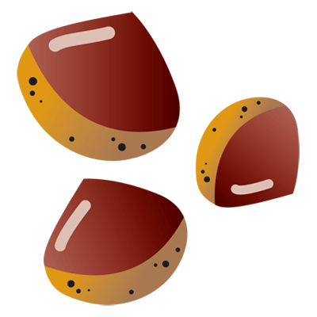 | 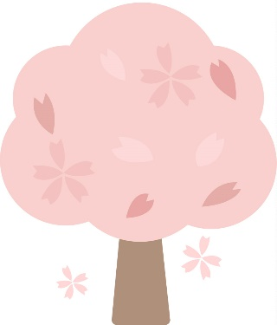 | 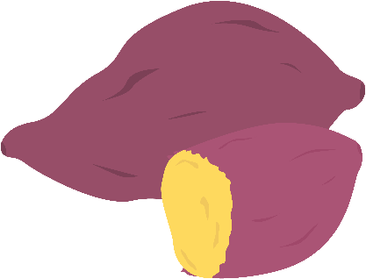
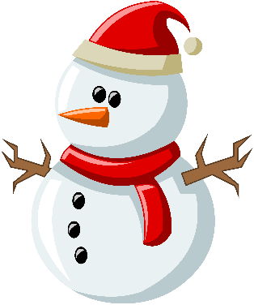 | 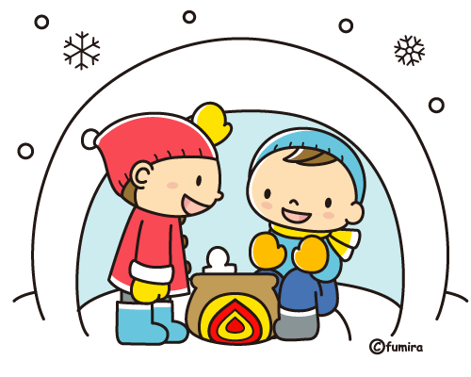

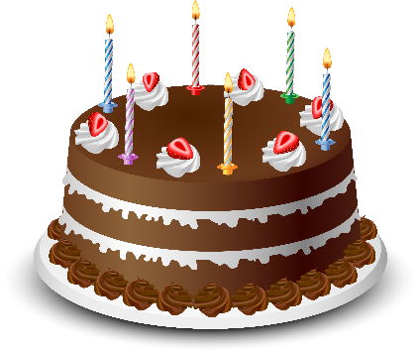 | 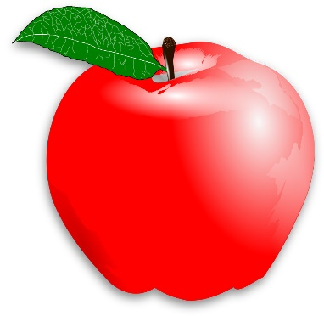 | 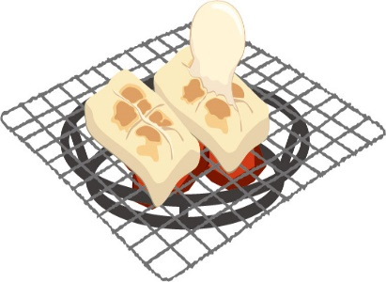
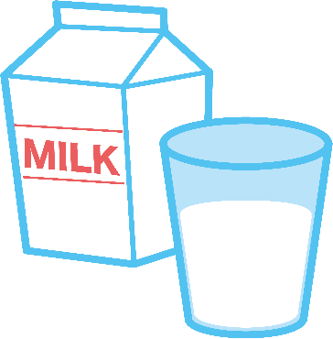

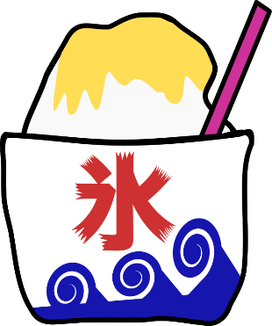 | 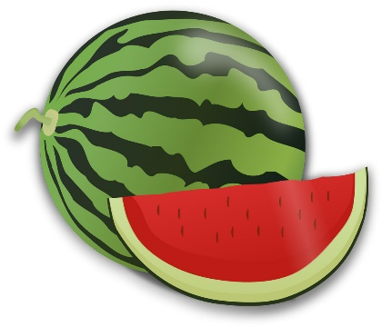 | 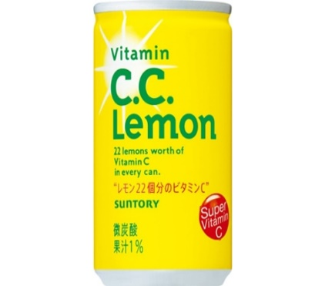
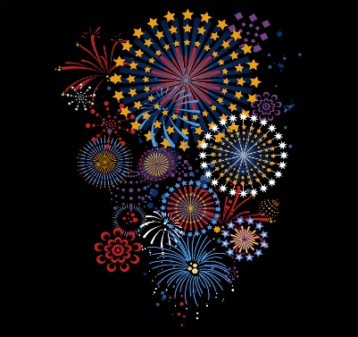 | 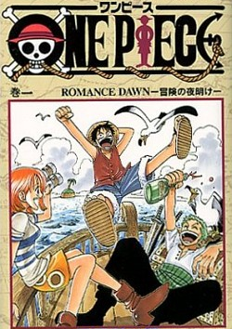 | 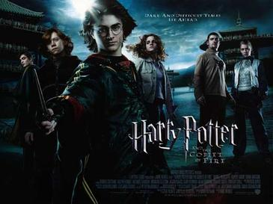
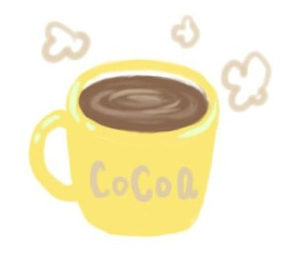 | 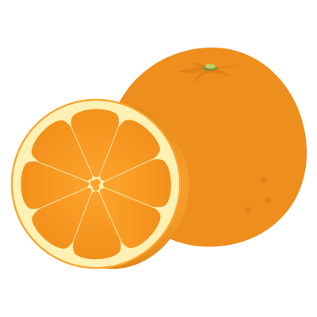 | 