National food!

Step1. Let’s think about national food！

National food

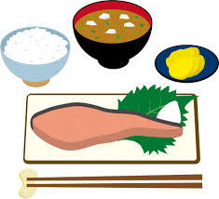
Step2. Q&A

- What is your favorite national food?

- Write two reasons. *reason… 理由

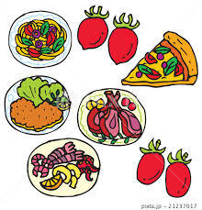
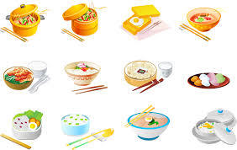

Step3. Let’s talk about your favorite food!
<model dialog>
A: Hello, how are you?
B: I’m (good/ happy/ not bad). How about you?
A: I’m (good/ happy/ not bad). Let’s talk about national food.
B: OK!
A: What is your favorite national food?
B: My favorite food is Chinese food.
A: Chinese food. Great.
B: I like Chinese food. It is delicious. I like nikuman.
A: Sounds nice.
B: Do you like Chinese food?
A: Yes, I do.
B: Great! So, what is your favorite national food?
A: Well… my favorite food is Indian food.
B: Indian food. I see.
A: I like Indian food. It is *spicy. I like curry and rice.
B: That’s nice.
A: Do you like Indian food?
B: No, I don’t. I don’t like spicy food.
A: That’s too bad. Nice talking with you.
B: Thanks, you too. *spicy…辛い

Name | National food | 理由
Ex/ Yusaku | Japanese food | healthy | miso soup

