This is ~.

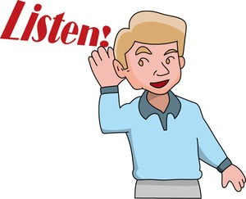
Step1. 話を聞いて四角の中を埋めよう！
もの | 色

Step2. listen carefully and make a circle(○)

- (This /That) is a red book.
- (This /That) is a black chair.
- (This /That) is a green file.

Today’s point!
This is my green file.
(訳: )
That is a black chair.
(訳: )
thisは（近く・遠く）にあるものを、
thatは（近く・遠く）にあるものをさす。
this の意味 ( ) 人を示すときは（ ）という意味
that の意味 ( ) （ ）という意味
友達を紹介しよう！
Haruki: Hello, B. How are you?
Saki : Hello, A. I’m fine. Thank you. And you?
Haruki : I’m fine, too. Saki, this is my friend Alex.
He is from Canada. He is good at soccer.
Alex, this is my friend Saki.
She is from Aichi. She is good at cooking.
Saki: Hello, Alex. Nice to meet you.
Alex: Hello, Saki. Nice to meet you, too.
word list  ・drawing a picture…絵を描くこと  ・running…走ること  ・singing…歌うこと | ・math…数学  ・science…理科  ・social studies…社会  ・Japanese…国語  ・P.E.…体育

Nice to meet you!

Name

I’m from

I’m good at

Name | I’m from… | I’m good at…

