|  |  |  |
| --- | --- | --- |
| [女優のイラスト](http://2.bp.blogspot.com/-JaE4FOcIpt8/VMItcDzAirI/AAAAAAAAqts/251ArshMARQ/s800/eiga_joyuu.png)    actress | [お医者さんのイラスト（全身）](http://1.bp.blogspot.com/-aa8DuSxqUvY/UgsxcYkGbFI/AAAAAAAAXXU/SsPSIQU5jGE/s800/job_doctor.png)  doctor | http://1.bp.blogspot.com/-wDplpGTV9TA/UgsxdNEQcyI/AAAAAAAAXXo/lZfmAj6YitY/s800/job_nurse.png  nurse |
| [先生・講師のイラスト](http://4.bp.blogspot.com/-GAVYMoV3F4M/UZYk0hIarTI/AAAAAAAATGc/A05ffniZ3i8/s800/job_senesi.png)  teacher | [警察官のイラスト（職業）](http://3.bp.blogspot.com/-wIyw0TKByCo/VlAZDE1qQXI/AAAAAAAA03s/WbZLC0kSTHI/s800/job_police_man.png)[■](http://4.bp.blogspot.com/-7fGOUe3fWaw/VlAZD3h-rUI/AAAAAAAA03w/OJGGKMcDh64/s800/job_police_woman.png)  police officer | [消防士と消防車のイラスト](http://2.bp.blogspot.com/-TVz3Ans6_TQ/Ut0BexyT_6I/AAAAAAAAdZw/GDQ4u7zVzwc/s800/syoubousya_housui.png)  firefighter |
| [パティシエのイラスト（女性）](http://1.bp.blogspot.com/-Cq1pVgjPmcI/UsZuFVzA7SI/AAAAAAAAc3Y/yowVVVEJsP0/s800/patissier_woman.png)  pastry chef | [■](http://3.bp.blogspot.com/-loBi8BDPNdM/VRE5JEYagnI/AAAAAAAAsZk/V2oKb4C1E98/s800/piano_solo.png)  pianist | [■](http://4.bp.blogspot.com/-nDWuIXRISVg/UUFxugsou3I/AAAAAAAAO0I/iUKxxrS6E3k/s1600/manzai.png)  comedian |

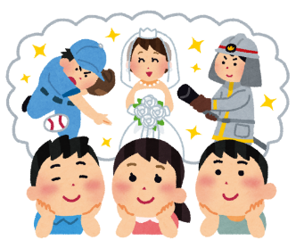**TIC TAC TOE**

|  |  |  |
| --- | --- | --- |
|  |  |  |
|  |  |  |
|  |  |  |