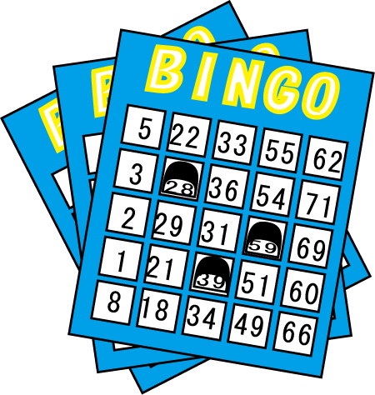
Bingo!
Class( ) No.( )Name( )
☆好きな場所に好きなカードを貼って（ ）の中easy/difficult を入れよう。
☆友達に質問をして３ビンゴそろえよう！
<会話例> Q : Is it difficult for you to play basketball?
A : Yes, it is. It is difficult for me to play basketball.

speak English  ( ) | Dance  ( ) | play the piano  ( )
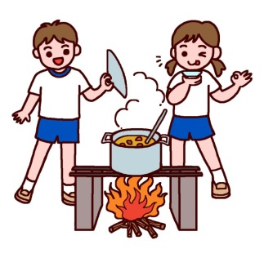  cook curry  ( ) | sing a song  ( ) | run fast  ( )
touch a tiger  ( ) | 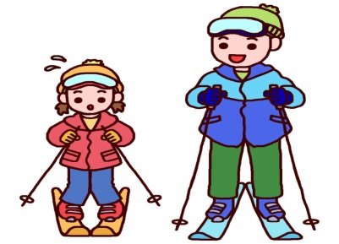  ski  ( ) | use a computer  ( )

