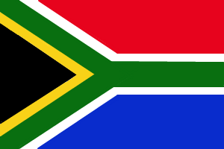
Lesson 9. Part.2.3: The Power to Unite People
Name ( )
Small talk：What is your favorite sports? Talk with your pair.
1. Look at the three pictures. Can you guess the story? Discuss with your partner.

2. Guess true or false before reading. Circle T or F.
1) Rugby was a sport for everyone. ( T / F )
2) Mandela wanted to play rugby at the World Cup. ( T / F )
3) Mandela went to the stadium to cheer the players. ( T / F )
4) The players tried the best only playing rugby. ( T / F )

Silent reading 1 : Time your speed by yourself. ( seconds)

3. Match the English words and Japanese ones.
be scheduled to…. ・ ・ 勝利
cheer ・ ・先頭を切って…..する
forgive ・ ・…..する予定になっている
victory ・ ・応援する
take the lead in…. ・ ・許す
slogan ・ ・巨大な
protest ・ ・ジャージ
jersey ・ ・スローガン
huge ・ ・反対の
opposing ・ ・抗議の
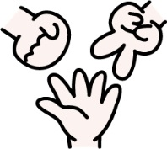
Play janken-pon. Winners say Japanese and losers translate into English. When you have finished, change the role. Please memorize all words and phrases : )

4. Read the story and answer the questions.
1) When was The Rugby World Cup scheduled to be held in South Africa?

2) Why didn’t black people cheer their national team?

3) What did Mandela wear on the day of the Springboks’ first game?

4) Why did Mandela cheer the Springboks’ players?

5) What is the slogan of the Springboks?

6) What became the huge power to win?

5. Reading practice
1 after teacher 2 only students 3 with partner

Silent reading 2 : Time your speed by yourself. ( seconds)

6. Retelling the story
Check the story with your partner by using these words. Play janken-pon, and winners first tell one sentence, losers continue to tell the story with one sentence.
South Africa / cheer / Springboks / Mandela / support / wore / interview / slogan / song
/ support / opposing / huge

Timed-conversation： Please answer these questions, and talk with your partner.
Who do you admire?
⇒
Where and when was the person born?
⇒
What has the person done or what does the person do?
⇒

Why has the person done it and does the person do it?
⇒

Conversation strategies

I think so, too. （私もそう思います。）/ I don’t think so.（私はそう思いません。）
/ I mean….. （つまり…）/ You mean…（あなたが言いたいのは…）
/ What do you think?（あなたはどう思いますか？）
How about you? （あなたはどうですか？）/ For example…. （例えば…）
/ Let me see…（そうだなぁ…） / Well…（えっと…）/ Uh….（えっと…） /
That’s right!（その通りです！）/Take your time.（時間とっていいですよ。）
/ It sounds like…（それは…のように聞こえる。） / Really?（本当？）
/ Do you know….?（あなたは…知ってますか？）

