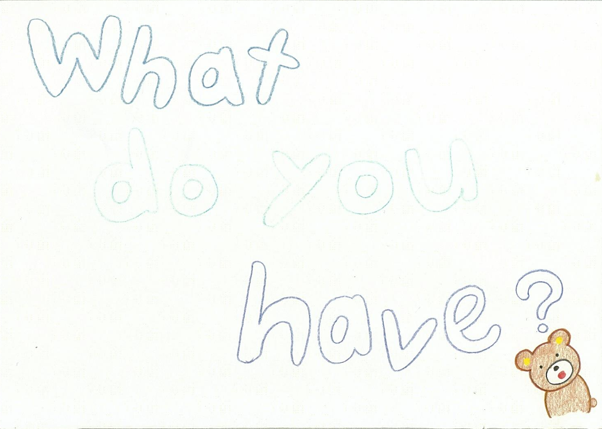

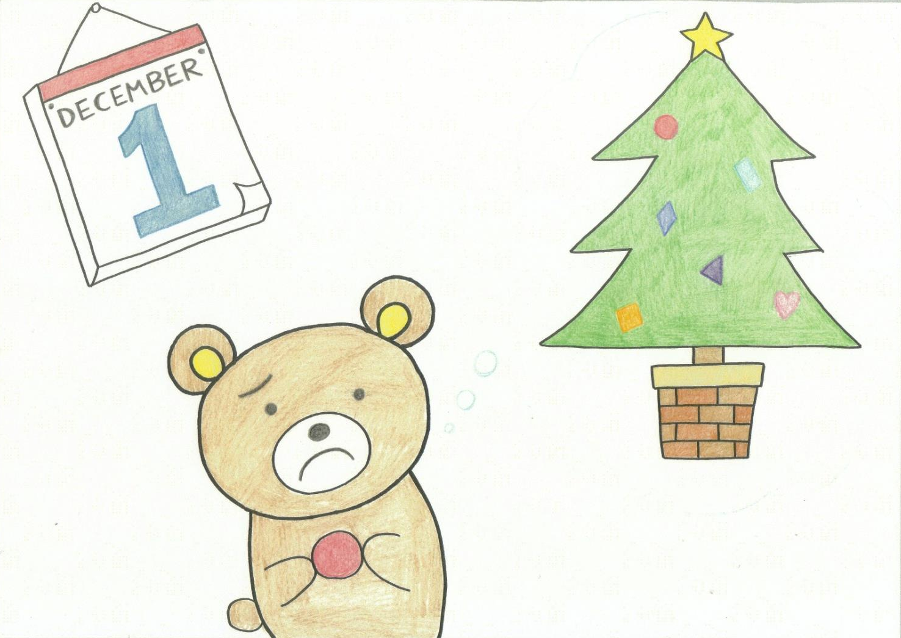

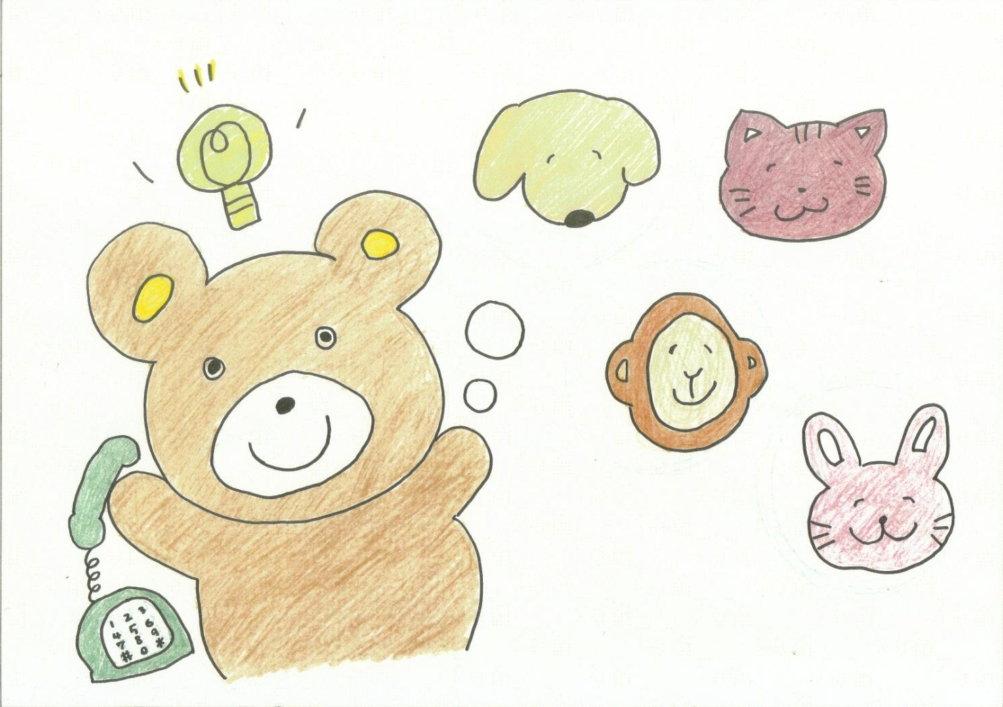

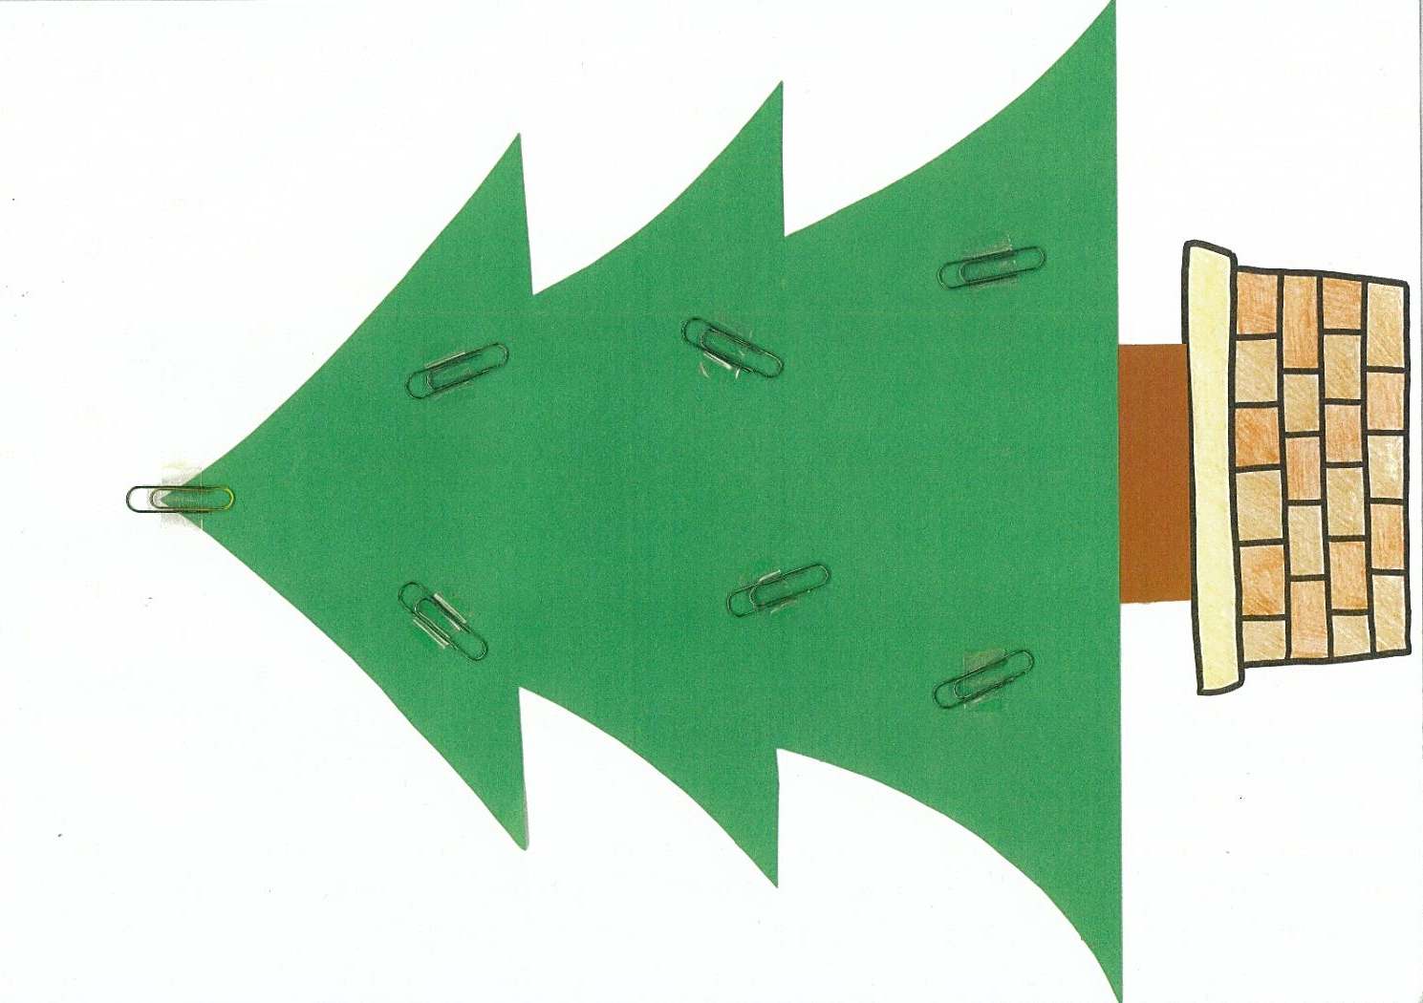

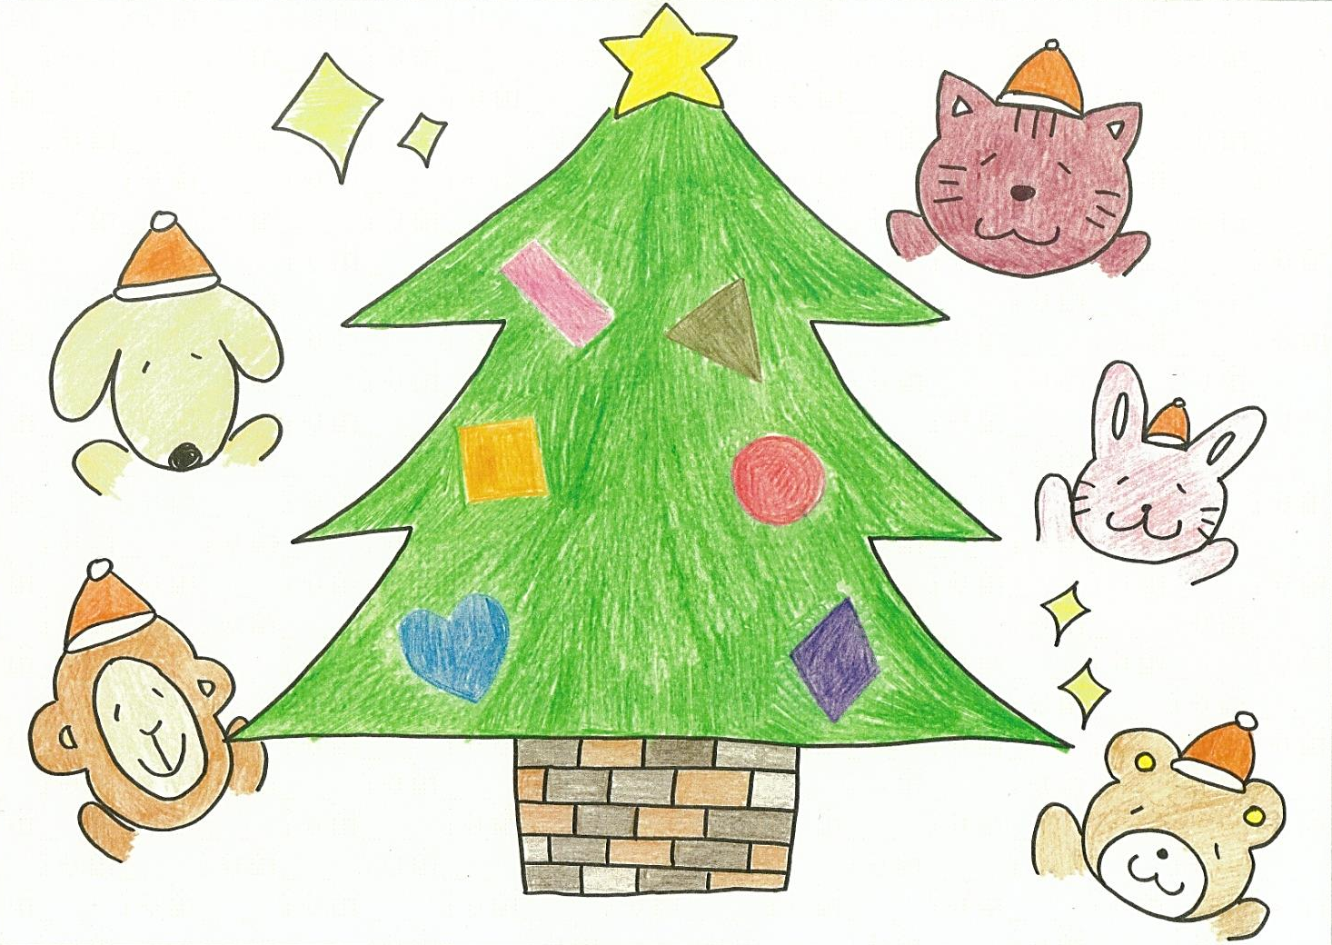

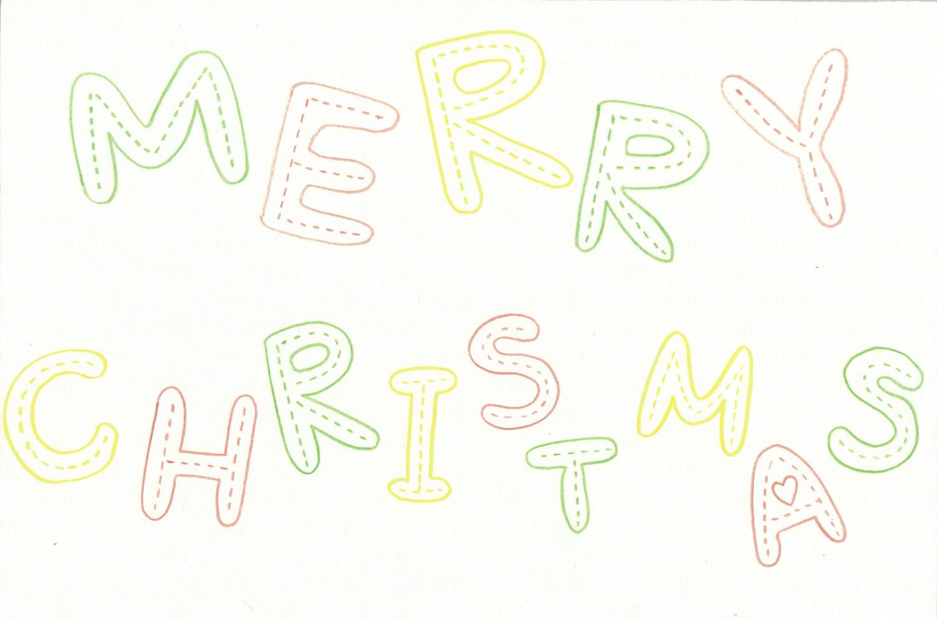

『What do you have?』
著者：Miku Hibino, Miyabi Harada, Ayano Noguchi
Bear: “Today is December 1st. I want to decorate Christmas three,
but I only have red circle. I need more decorations. Let’s call my friends!”

“Knock, knock!”
Dog: Hi, bear!
B: Hi, dog! What do you have?
D: I have a blue heart.
B: Thank you. Put it on the tree.

“Knock, knock!”
Cat: Hi, bear!
B: Hi, cat! What do you have?
C: I have a pink rectangle and an orange square.
B: Thank you. Put them on the tree.

“Knock, knock!”
Monkey: Hi, bear!
B: Hi, monkey! What do you have?
M: I have a gold triangle.
B: Thank you. Put it on the tree.

“Knock, knock!”
Rabbit: Hi, bear!
B: Hi, rabbit! What do you have?
R: I have a purple diamond.
B: Thank you. Put it on the tree.

B: We need one more decoration!
Teacher: Can you guess everyone?
Students: Star!!
C: Oh! We need a star!, but where is a star?
M: Look, look! Bear, you have a star in your hat.
R: Put it on top of the tree!

B: We made our Christmas tree!
All: Happy Merry Christmas!!

