

**Worksheet①**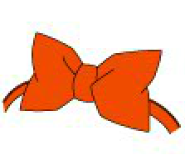

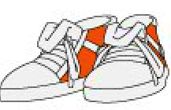a)

●

●

●

●

●

●

①This has an electricity and magnetic force inside. Conan uses this when he stops someone from running away.

●

●

●

●

●

●

Bow Tie voice Transmitter

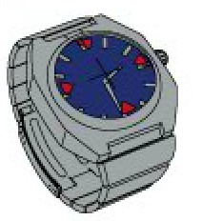

b)

Wrist Watch with Stun Gun

②This has a button to stretch. Conan uses this to lift something heavy.

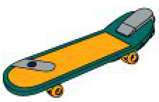

c)

Skateboard with turbo engine

③This has a button to go very fast.　Conan uses this when he is chasing someone.

d)

Super sneakers

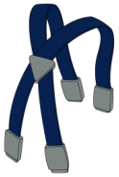

④This has a dial to change a voice. Conan uses this when he imitates someone.

e)

⑤This has a micro transceiver inside. Conan uses this when he wants to contact with someone having one.

Ever stretch suspender

f)

★**If + S + ( ),**  **S + ( ) / ( ) / ( ) + Verb.**

★put a name of invention and fill in the blanks below.

1. If I had ( ) , I could stop my mother when she is talking.
2. If I had ( ) , I might be a hero in a soccer game.
3. If I had ( ) , I mightn’t be lost my way.
4. If I had ( ) , I could lift anything heavy.
5. If I had ( ) , I wouldn’t be late for school.
6. If I had ( ) , I would imitate celebrities.

Class( ) No.( ) Name( )

Detective badge

⑥This has a button to shoot off a needle with anesthesia. Conan uses this when he makes someone fall asleep.

a)Bow Tie voice Transmitter

b)Wrist Watch with Stun Gun

c)Skateboard with turbo engine

d)Super sneakers

e)Ever stretch suspender

f)Detective badge