時間割を完成させよう!!
A
 | Monday | Tuesday | Wednesday | Thursday | Friday
１ | 学活
２ |  |  |  | 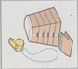
３ |  |  |  |  | 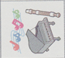
４ |  |  | 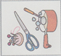
５ |  |  |  |  | 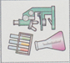
６

29
時間割を完成させよう!!
B
 | Monday | Tuesday | Wednesday | Thursday | Friday
１ | 学活
２
３
４
５
６
30

