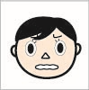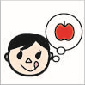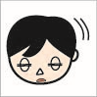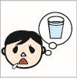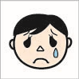

angry

name

name

name

name

name

name

name

sad

sleepy

tired

thirsty

happy

hungry