Step 4 : Let’s Read ①

本文を読んで下の質問に答えよう。
- A big bomb fell on Hiroshima in the morning. ( T / F )
- The girl tried to be a mother to the poor little boy. ( T / F )
- A little boy stopped crying and started to sing a lullaby. ( T / F )

Step 5 : New Vocabularies 2

（文から下線部の単語の意味を予想してイラストとマッチしよう）

(a) Everyone thought he was dead.
(b) Small animals are weak, so they form a flock to survive. *flock-群れ*
(c) Lullaby is a quiet song to send a child to sleep.
(d) On the last day of summer vacation, he still hasn't finished his homework.
(e) You have to have a rest in the shade of that tree.

( )  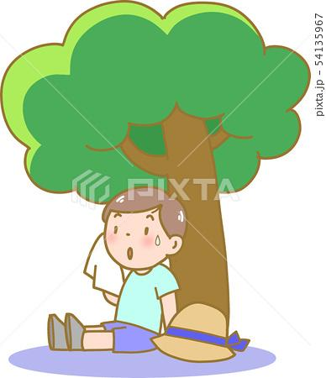 | ( )  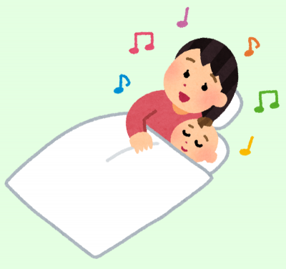 | ( )  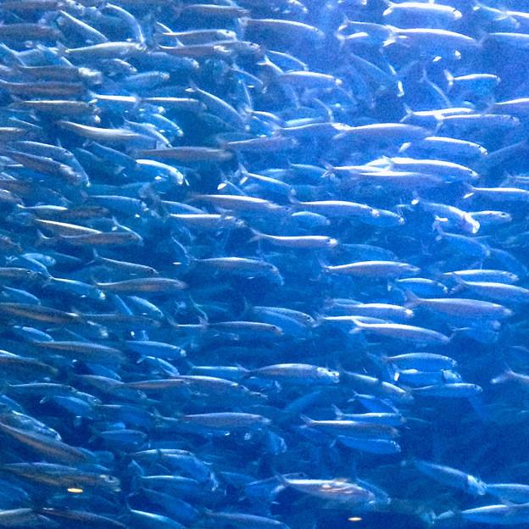 | ( ) | ( )  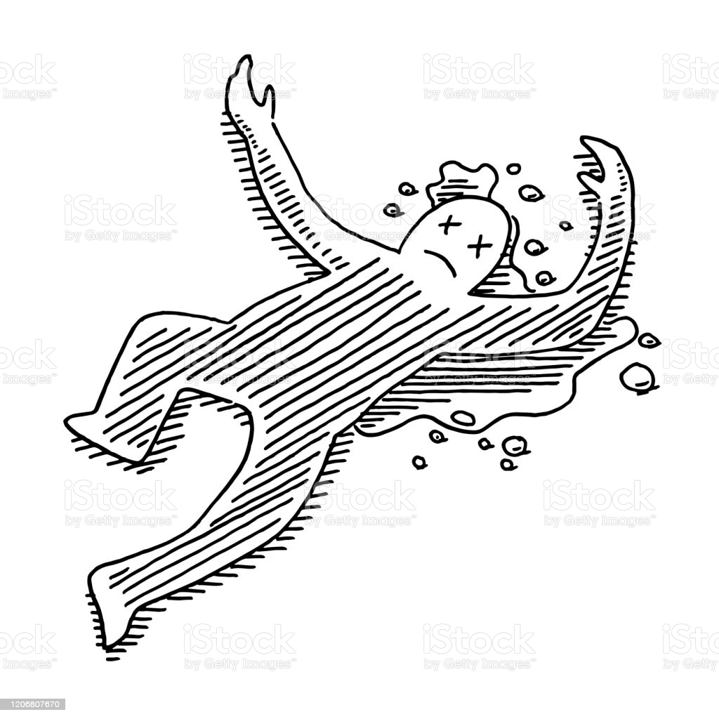

Step 6 : Let’s Read ②

本文をもう一度読んで下の質問に答えよう。

１．Where does the big old tree stand?

_______________________________________________________________________________________________

- When did the big bomb fall on Hiroshima?

_______________________________________________________________________________________________

- Why did the boy stop crying?

_______________________________________________________________________________________________

- The girl didn't move when the sun rose. Why?

_______________________________________________________________________________________________

