オンリーワンになろう！

Step1. 先生の話を聞いて、聞きとれたことを書こう！

Step2. もう1度先生の話を聞いて、聞き取れた方に〇をつけよう！

1. I was in badminton club in my junior high school, so I (can/ cannot) play badminton well.
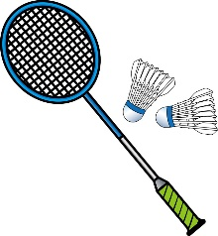
2. I don’t like carrot, so I (can’t/ can) eat carrot.

3. My brother joined tennis club, so he can (play/ played/ plays) tennis very well.
But he (can’t/ can) play badminton well.

Step3. 今日のポイント

I can play badminton well
日本語訳 ( )
なのでcanの意味は( )という意味になる。
否定の意味にするには( )を使う。これを短縮するには( )と書く。
主語が三人称の場合、動詞は( )にする。

4. オンリーワンを決めよう！

Your special ability
EX. I can バク転.

<Model Dialog>
Do the じゃんけん. A is winner. B is loser.
A: Hi, how are you?
B: (I’m fine/ not so bad/ I’m not feeling….). How are you?
A: (I’m fine/ not so bad/ I’m not feeling….). What’s your special ability?
B: I can バク転.
A: I can do that! → B can’t get 1 point.
I can’t do that! You are great! → B can get 1 point.
B: How about you? (change roles)

Classmate’s special ability
Your friend’s name | What is his/ her special ability?

What’s your point?

points!

