Step 1 先生の話をもとに答えよう！

- Q. How long have I done face mask?

A. For 1 week. B. For 2 weeks. C. For 3 weeks.

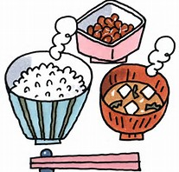
- Q. How long has my brother eaten breakfast?

- Since he was a kindergarten student.
- Since he was an elementary school student.
- Since he was a junior high school student.

- Q. How long has my mother soaked in the bathtub?
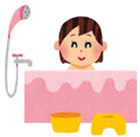
- For 5 years.
- For 10 years.
- For 20 years.

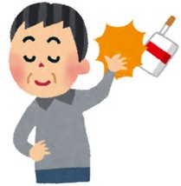
4) Q. How long has my father quit smoking?
A. Since I was born.
B. Since he had heart sick.
C. since my mother advised to him.

Step 2 かっこの中をうめよう！
1) Q. ( )( ) have I done face mask?
A.( ) 2 weeks.

2) Q.( )( ) has my brother eaten breakfast?
A. ( ) he was a junior high school student.

3) Q. How long ( ) my mother soaked in bathtub?
A. ( ) 20 years.

4) Q. How long ( ) my father quit smoking?
A. ( ) he had heart sick.

Step 3 まとめ
◎復習 現在完了形（継続）
Ex) I have done face mask for 3 weeks.
( )
have/has＋（ ）～ for/since～

☆どれくらい続けてるか質問するときは
Q：（ ）（ ）（ / ）＋主語＋過去分詞～？
A：For＋( ) . / Since ＋( ).

Step 4 聞いてみよう！有名人の良い習慣！
Rules
・自分の知らない有名人の良い習慣をペアに聞いてみよう。
・じゃんけんで勝った人から始めよう。
Model dialog
A,B: Hello.
A: Do you know ○○’s good habit?
B: Yes, I do. His/her good habit is ~.
A: I see. How long has he/ she done it?
B:He/She has ~ .
A: That’s nice! / Sounds good. / Wow! / I want to try it. Etc.
AとBが交代する。

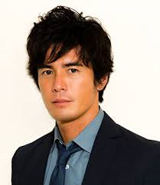  Hideaki Ito | Kasumi Arimura  do muscle training  since she became an actress  do‐did‐done | Minami Tanaka | 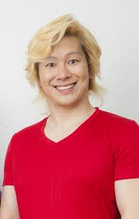  Kazu Re-za-  read many books  since he was a college student  read‐read‐read
Ryoko Shinohara  do yoga  for 10 years  do‐did‐done | Nicole Fujita | 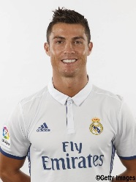  C・Ronaldo  eat a lot of proteins  for 5 years  eat‐ate‐eaten | 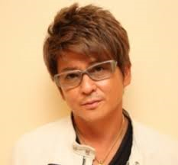  Syo Aikawa
A
Step 5 真似したい良い習慣を書こう
What is his/her good habit?

How long has he/she done?

