いつ始めたかな？？

Step1 英文を読んで空欄に数字をいれよう！！

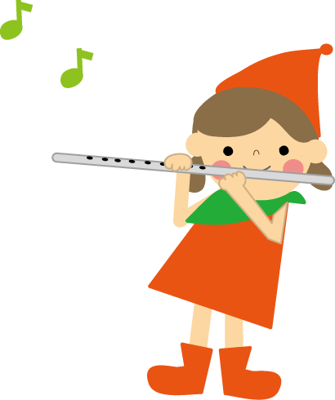
I started playing the flute nine years ago.
I still play the flute now.
So, I have played the flute for years

Mrs. Endo started working at NUFS last year.
She still works at NUFS now.
So, she has worked at NUFS since .

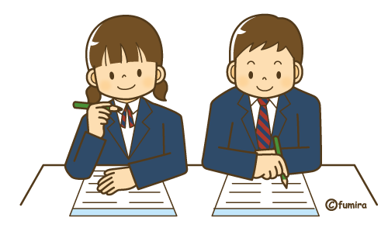
We started studying English in 2013.
We still study English now.
So, we have studied English for years.

Step2 今日のまとめ！！
- I have played the flute for nine years.
訳 （ ）
☆have ＋ （ ）→ 意味（ ）
☆この用法のことを（ ）の（ ）という。
☆for : （ ） since : （ ）

Step3 何年間続けているか当てよう！！
A

(1) Ichiro  play baseball  33 years | (2) Nishikori Kei  play tennis  ( years )  ( guess ) | (3) Hakase Taro  play the violin  43 years
(4) Sakurai Sho  belong to Arashi  ( years )  ( guess ) | (5) Paul  live in Japan  22 years | (6) Takahashi Minami  belong to AKB48  ( years )  ( guess )
(7) Atsugiri Jason  study Japanese  10 years | (8) Obama  marry with Michelle  ( years)  ( guess )

＜語群＞ １０、１６、１８、２０、２３、２５、３０

＜model dialog>
A : I think Ai has played the flute for nine years.
B : That’s right. / That’s wrong. →正しい答えを言う
Ai has played the flute for years.

Step4 知った情報を英文で書こう！！

Step3 何年間続けているか当てよう！！
B

(1) Ichiro  play baseball  ( years )  ( guess ) | (2) Nishikori Kei  play tennis  ２０ years | (3) Hakase Taro  play the violin  ( years )  ( guess )
(4) Sakurai Sho  belong to Arashi  16 years | (5) Paul  live in Japan  ( years )  ( guess ) | (6) Takahashi Minami  belong to AKB48  10 years
(7) Atsugiri Jason  study Japanese  ( years )  ( guess ) | (8) Obama  marry with Michelle  23 years

＜語群＞ １０、２2、２３、３３、３５、４３、４７

＜model dialog>
A : I think Ai has played the flute for nine years.
B : That’s right. / That’s wrong. →正しい答えを言う
Ai has played the flute for years.

Step4 知った情報を英文で書こう！！

