早起きした理由は？？

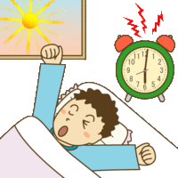
<Step1> 空欄をうめよう！！
Q. なぜ先生は早起きしたのかな？
１．
２．
３．

<step2> かっこをうめよう！！
１．I got up early ( ) make a lunch box.
２．I got up early ( ) do my homework.
３．I got up early ( ) ( ) do Radio-Taiso.

<step3> まとめ！！
- I got up early to make a lunch box.
訳 ( )

☆to ＋（① ）で、（② ）という意味になる。
☆to ＋（① ）の形を（③ ）という。

I go to a kitchen  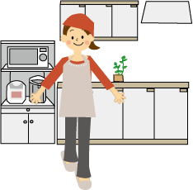 | 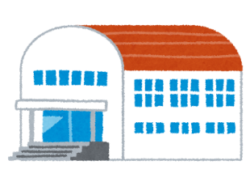  I go to a gym | 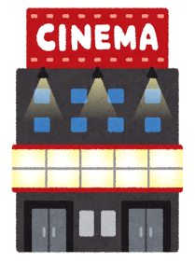  I go to a cinema | I study English | 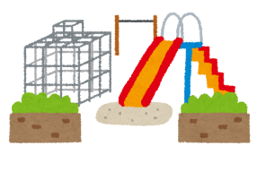  I go to a park
to cook dinner. | to play basketball. | 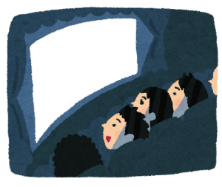  to watch a movie. | to be a teacher. | 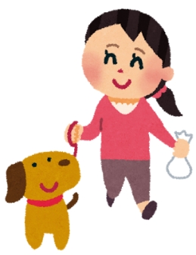  to walk my dog
I use a smart phone | I work hard | I go to the sea | 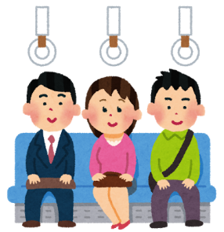  I ride a train | I go to Tokyo  Tokyo
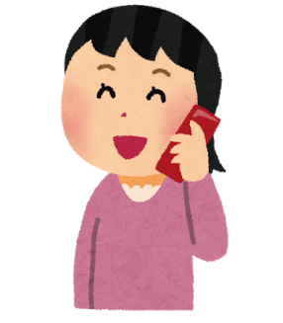  to call my mother | 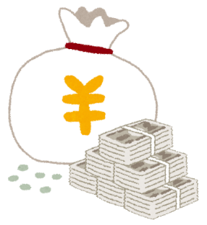  to get money | to go fishing | 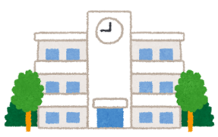  to go to school | to visit Tokyo Sky Tree

