English is interesting.

<Step1>先生の話を聞いて、表にまとめよう！
好きな教科 | 嫌いな教科

<Step2>聞こえた方に○をつけよう！
(1) I like English very much. English (is / are) interesting.
(2) I like Japanese. Japanese is (easy / difficult).
(3) I don’t like math. Math is (no / not) easy. Math is difficult.

<Step3>まとめ
◎ English is interesting. (訳. )
・( ) = (is, am are)のうしろに( )がきて、
( )を説明する。
◎ Math is not easy. (訳. )
・否定をするときは、( )を( )のまえにおく。

<Step4>英語？簡単？難しい！いやいや面白いでしょ！ゲーム
◎Let’s check vocabularies!
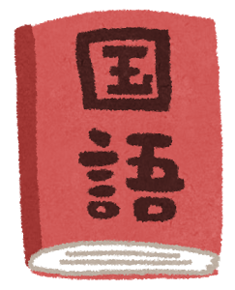 | 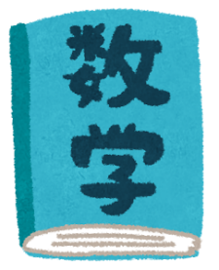 |  | 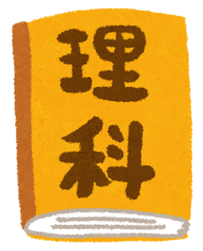 | 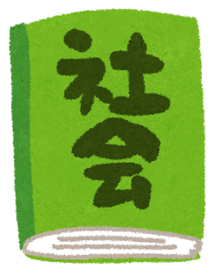 | 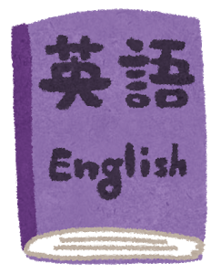

interesting … boring …
funny … exciting …
easy … difficult …

Your name | Subject① | Subject② | Subject③

＜ルール＞
①自分と同じことを考えている人を見つけよう。
②聞けるのは５人まで。
③一つ同じで１点、二つ同じで２点、三つとも同じだと３点＋ボーナス１点
で４点ゲット！
④モデルダイアログを使って聞きまくろう！
⑤会話が終わったらメモをとって、ポイントを計算しよう。

<Model Dialog>じゃんけんをして勝った方がA
A: Hello, how are you?
B: Hello, I’m fine.(great/ good/ so-so/ bad etc…). Thank you. And you?
A: I’m fine.(great/ good/ so-so/ bad etc…). So, Do you like English?
B:①Yes, I do. I like English. English is interesting.
②Yes, I do. I like English. English is easy.
③No, I don’t. I don’t like English. English is difficult.
A:①に対して I think so, too!
②③に対して Really?/ Oh, you don’t like English.
How about Japanese?
B:①Yes, I do. I like Japanese. Japanese is interesting.
②Yes, I do. I like Japanese. Japanese is easy.
③No, I don’t. I don’t like Japanese. Japanese is difficult.
A:①に対して I think so, too!
②③に対して Really?/ Oh, you don’t like Japanese.
How about math?
B:①Yes, I do. I like math. Math is interesting.
②Yes, I do. I like math. Math is easy.
③No, I don’t. I don’t like math. Math is difficult.
(take turn)
AB: Nice talking with you!!

name | Subject① | Subject② | Subject③ | Points

name | Subject① | Subject② | Subject③ | Points

Total

<Step5>書いてみよう！

