**クイズ大会**

**Class( ) No.( ) Name( )**

**<Step1> Let’s think!**

**①**

 is an actress. (女優)

She appeared on TV at 9 p.m. on Monday　from September to December.

So,  is the actress who appeared on TV at 9 p.m. on Monday from October to December.

**Who is she?**

She is. 

**②**

 is a rugby player.

He is famous for the pose of the routine.

So,  is the rugby player who is famous for the pose of the routine.

**Who is he?**

He is .

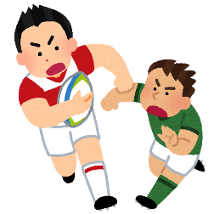

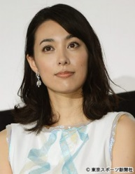

**③**

 is a singer.

He married Kazue Fukiishi.

So,  is the singer who married Kazue Fukiishi.

**Who is he?**

He is .

**④**

 is a singer.

She is a captain of AKB48.

So,  is the singer who is the captain of AKB48.

**Who is she?**

She is .

**<Step2> まとめ**

|  |
| --- |
| **・**Masaharu Fukuyama is a singer. **+** He married Kazue Fukiishi.  (訳. ) (訳. )  **→** Masaharu Fukuyama is the singer **who** married Kazue Fukiishi.  (訳. )  **・** “ who ” は ( ) を詳しく説明している。  **・**この “ who ” のことを ( ) という。 |

**<Step3> クイズ大会！**

|  |
| --- |
| (じゃんけん)  A(winner): Hello. Who is he/she?  This is the man/woman ①who . Who is he/she?  B(loser): He/She is . Right?  (正解の場合)  A: Yes, that’s right!  B: Oh, really? So, next is my turn. Who is he/she?  This is the man/woman ①who . Who is he/she?  A: He/She is . Right?  B: Yes, that’s right!  (不正解の場合)  A: No…  B: Oh, really? So, please give me the next hint.  A: OK. This is the man/woman ②/③who . Who is he/she?  B: He/She is . Right? |

**<Your hints>**

This is the man/woman ① .

② .

③ .

|  |  |  |
| --- | --- | --- |
| **①**  **3points** | **①＋②**  **2points** | **①＋②＋③**  **1points** |
|  |  |  |

計



