Do you know these?
1. This is a food.  2. It is made from milk.  3. When we make a pizza, we use the food.  What is this?  ( cheese / yakult )  So, ( cheese / yakult ) is a food made from milk. | 1. This is an animal.  2. It is living on the ground.  3. This animal has a long nose.  What is this?  ( an elephant / a lion )  So, ( an elephant / a lion ) is an animal living on the ground.
1. This is a person.  2. He taught English in high school.  3. He is from America.  Who is he?  ( Mr. Crane / Mr. Ohashi )  So, ( Mr. Crane / Mr. Ohashi ) is a person teaching English. | 1. This is a person.  2. She was born in Heian period.  3. She wrote the Tale of Genji.  Who is she?  ( Sei Shounagon / Murasakishikibu )  So, ( Sei Shounagon / Murasakishikibu ) is a person born in Heian period.

Grammar Point!
This is a food made from milk.
(訳: )

Mr. Crane is a person teaching English.
（訳: ）

- made from milk が a food を
２．teaching English が a person を

過去分詞形を使うときは（～ …）
~ing形を使うときは（～ …）という意味になる。

Matching Game!

<Model Dialog>
This is a person.  He is sleeping on the bed.  So…  This is a person sleeping on the bed.  ↓  You can get the cards!  Next turn…. | 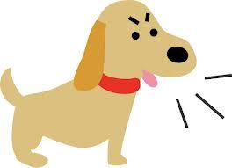  This is an animal.  It is built in 1958.  So…  This is an animal built in 1958.  ↓  You cannot get the cards.  Turn over these cards.  Next turn…

Let’s review today’s point!
アクティビティで使った表現を書こう！

This is a person. | 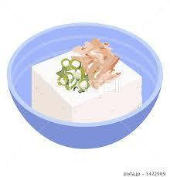  This is a food.
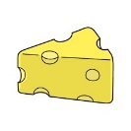  This is a food. | 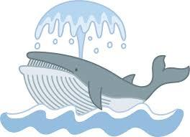  This is an animal.
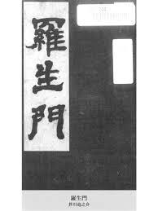  This is a book. | This is a character.
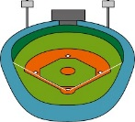  This is a place. | This is a person.
This is a museum. | This is an animal.
This is a person. | This is a sword.

She is playing tennis. | It is made from soybeans.
It is living in the sea. | It is made from milk.
It is watching a TV now. | It is written by Dazai Osamu.
She is listening to music. | It is played a baseball game yesterday.
It is running with a child. | It is built in 1958.
He is sleeping on the bed. | It is used in the Edo period.

