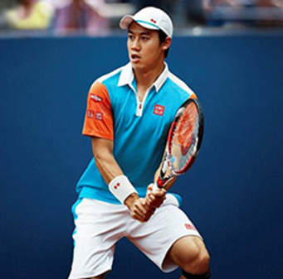  This man plays tennis. | 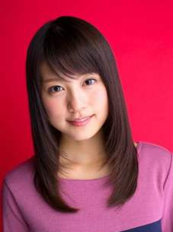  This woman is a cute actress. | 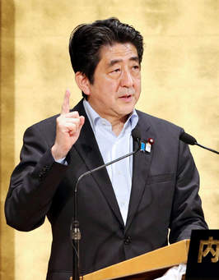  This man is the top of Japan. | 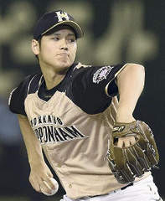  This man is a wonderful baseball player.
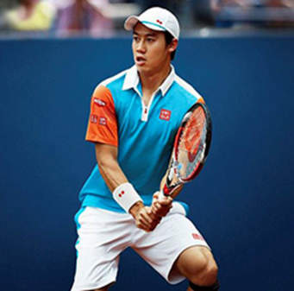  He is Nishikori Kei. | She is Arimura Kasumi. | He is Abe Shinzo. | He is Otani Shohei.
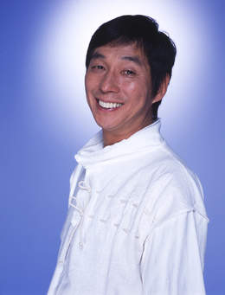  This man talks a lot. | 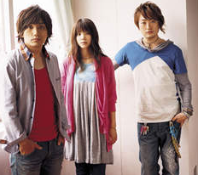  This woman sings songs very well. | This woman dances well. | This girl is a famous model.
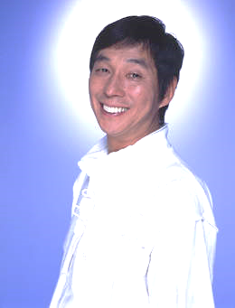  He is Akashiya Sanma. | She is Yoshioka Kiyoe. | She is Watanabe Naomi. | She is Fujita Nikoru.
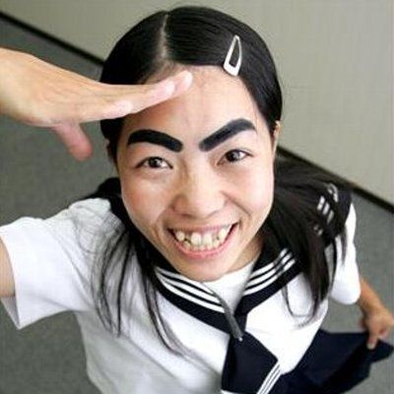  This woman travels in the world. | She is Imoto. | 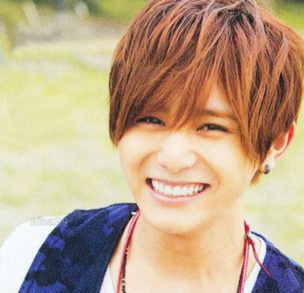  This man sings and acts. | He is Yamada Ryosuke.

