apple 200 yen | apple 200 yen | apple 200 yen
banana 100 yen | banana 100 yen | banana 100 yen
orange 200 yen  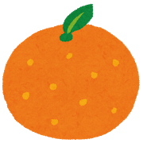 | orange 200 yen | orange 200 yen
lemon 300 yen | lemon 300 yen | lemon 300 yen

melon 500 yen | melon 500 yen | melon 500 yen
T-shirt 500 yen  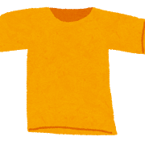 | T-shirt 500 yen | T-shirt 500 yen
bag 600 yen  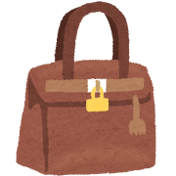 | bag 600 yen | bag 600 yen
cap 400 yen | cap 400 yen | cap 400 yen

pen 100 yen  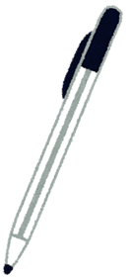 | pen 100 yen | pen 100 yen
notebook 200 yen | notebook 200 yen | notebook 200 yen
eraser 100 yen | eraser 100 yen | eraser 100 yen
ruler 300 yen | ruler 300 yen | ruler 300 yen

Shopping List  □apple 3個  □notebook 2冊  □bag 1つ | Shopping List  □lemon 3個  □pen 3本  □T-shirt 1着
Shopping List  □orange 3個  □ruler 2個  □cap 1つ | Shopping List  □melon 1個  □notebook 2冊  □cap 2つ
Shopping List  □banana 3個  □eraser 3個  □T-shirt 2着 | Shopping List  □banana 3本  □eraser 2個  □bag 2つ

○左側の買い物リストは１６０円分の買い物、右側の買い物リストは１７０円分の買い物ができるようになっている。

100 yen | 100 yen | 100 yen | 100 yen | 100 yen
100 yen | 100 yen | 100 yen | 100 yen | 100 yen
100 yen | 100 yen | 100 yen | 100 yen | 100 yen
100 yen | 100 yen | 100 yen | 100 yen | 100 yen

100 yen | 100 yen | 100 yen | 100 yen | 100 yen
100 yen | 100 yen | 100 yen | 100 yen | 100 yen
100 yen | 100 yen | 100 yen | 100 yen | 100 yen
100 yen | 100 yen | 100 yen | 100 yen | 100 yen

100 yen | 100 yen | 100 yen | 100 yen | 100 yen
100 yen | 100 yen | 100 yen | 100 yen | 100 yen
100 yen | 100 yen | 100 yen | 100 yen | 100 yen
100 yen | 100 yen | 100 yen | 100 yen | 100 yen

100 yen | 100 yen | 100 yen | 100 yen | 100 yen
100 yen | 100 yen | 100 yen | 100 yen | 100 yen
100 yen | 100 yen | 100 yen | 100 yen | 100 yen
100 yen | 100 yen | 100 yen | 100 yen | 100 yen

