FRANCE
Name
（名前）
How long are you going to stay? 1 month
（滞在期間）
Purpose work/ study/ sightseeing
（渡航目的）
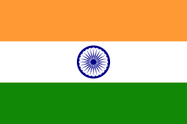
INDIA
Name
（名前）
How long are you going to stay? 2 weeks
（滞在期間）
Purpose work/ study/ sightseeing
（渡航目的）
SPAIN
Name
（名前）
How long are you going to stay? 1 year
（滞在期間）
Purpose work/ study/ sightseeing
（渡航目的）
BRAZIL
Name
（名前）
How long are you going to stay? 5 years
（滞在期間）
Purpose work/ study/ sightseeing
（渡航目的）
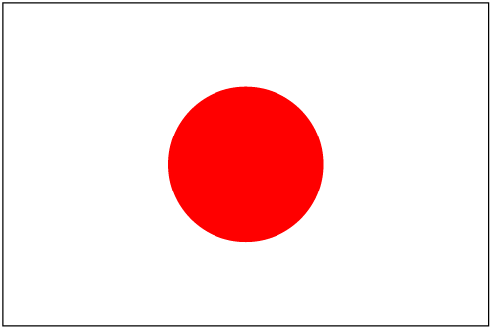
JAPAN
Name
（名前）
How long are you going to stay? 6 months
（滞在期間）
Purpose work/ study/ sightseeing
（渡航目的）
AMERICA
Name
（名前）
How long are you going to stay? 4 years
（滞在期間）
Purpose work/ study/ sightseeing
（渡航目的）
KOREA
Name
（名前）
How long are you going to stay? 3 weeks
（滞在期間）
Purpose work/ study/ sightseeing
（渡航目的）
AUSTRALIA
Name
（名前）
How long are you going to stay? 1 year
（滞在期間）
Purpose work/ study/ sightseeing
（渡航目的）
CANADA
Name
（名前）
How long are you going to stay? 2 weeks
（滞在期間）
Purpose work/ study/ sightseeing
（渡航目的）
ITALY
Name
（名前）
How long are you going to stay? 3 years
（滞在期間）
Purpose work/ study/ sightseeing
（渡航目的）

