Lesson 3: The Power to Unite People
Name ( )
<Review – What do you remember?>
Make brainstorms on “Mandela” and “Springboks”. What can you remember?

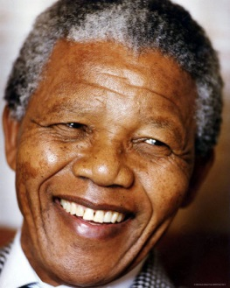
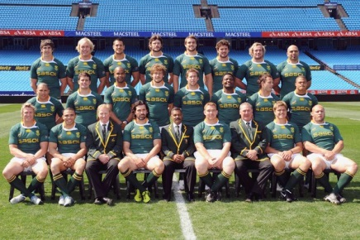

<Pre-reading task>
- Do you think Springboks can win All Blacks? (They are the strongest team in the world!!)
(A. _______________________________________________________________.)
- Do you think Springboks is happy to get support from blacks? (The players are white.)
(A. _______________________________________________________________.)
- Why did Mandela support Springboks?
- _______________________________________________________________.)

<Prediction of the story – What will happen?>
Read two questions below, and guess the answers.

- What do you think the captain of the Springboks say to a TV report after their victory?
- _______________________________________________________________.)
- What do you think Mandela say about sport?
- _______________________________________________________________.)
Share your ideas with your partner, and decide the best guess for each question.

- (A._______________________________________________________________.)
- (A._______________________________________________________________.)

<Vocabulary quiz>
Match the words and meanings!

score ○ ○得点
moment ○ ○答える、返事する。
historic ○ ○レポーター
reporter ○ ○（特定の）時
reply ○ ○歴史的な
inspire ○ ○政府
powerful○ ○障害
government ○ ○鼓舞する
racial ○ ○強力な
barrier ○ ○人種の、民族の

<Comprehension Check! - True of false>
- When Springboks won, blacks and whites fought against each other. T/F
- The captain of the Springboks said only a few South Africans supported the team. T/F
- Mandela said sport does not have power to break racial barriers. T/F

---------------------------------------------------------------------------------------------------------

<Memory challenge game - Real or no real>
You are going to make three true or false questions about the story. Try to use paraphrasing.
Q1.__________________________________________________________________.
Q2.__________________________________________________________________.
Q3.__________________________________________________________________.

 | Partner 1 | Partner 2 | Partner 3 | Partner 4
Q1
Q2

<Timed-conversation>
Answer the questions below, and talk about “the person you admire” with your partner.

A person you admire: _________________________________.

Where and when was the person born?
Place:_______________________________________________________________.
Time:_______________________________________________________________.

What has the person done, and what does the person do?
1.___________________________________________________________________.
2.___________________________________________________________________.

Why has the person done it, and why does the person do it?
1.___________________________________________________________________.
2.___________________________________________________________________.

Why do you admire the person?
1.__________________________________________________________________.
2.__________________________________________________________________.
3.__________________________________________________________________.

<Conversation Strategies>
I think so, too.（私もそう思います） /I don’t think so. （私はそう思いません）
/ I mean…. （つまり～） / You mean ….（あなたが言いたいのは～） /
What do you think? （あなたはどう思う？）/
How about you? （あなたはどうですか?） / For example…（例えば～）/
Let me see…（そうだなぁ･･･。）/ Well…（えっと･･･。） / Uh…（えっと･･･。）/
That’s right! （その通り!）/ Take your time.（時間とっていいですよ） /
It sounds like…（それは～のように聞こえる）/ Really?（本当？）/
Do you know…?（あなたは～を知ってますか？）

